Trox

Business Requirements Document

Project: Trox

Author(s): Viktorija Grillo, Saurabh Rai, Nihal Suresh,Nihar, Ankit Lele, Kunxi Grisworld, Mrudul Ghagor

Table of Contents

**1.** **Project Overview** 3

**2.** **Document Information** 3

2.1 Audience 3

**3.** **Business Opportunity** 3

3.1 Project Overview and Background 3

3.2 Current State Analysis 4

3.3 Future State Objectives 4

3.4 Business Domain Model and Stakeholders 4

**4.** **Business Requirements** 5

4.1 Details of Business Requirements 5

**5.** **Non-Functional Requirements** 7

**6.** **External Data Feeds** 7

**7.** **Business Risks** 8

# **Project Overview**

This document describes the business/user requirements for the Trox web applications that will provide the basis for the following project activities:

* Introducing business/user requirements
* Creating test plans and test specifications
* Identifying stakeholders
* Devising solutions to project tasks
* Produce an application that will enable customers to buy products from the website and customers can also put products for sale.
* Determining when the project is complete
* Assessing the degree to which the project succeeded

# **Document Information**

## 2.1 Audience

| Name | Business Group | Role |
| --- | --- | --- |
| Customers | Orders & Delivery Department, Customer’s Service Department | Web Application Users |
| Ad Agencies | Marketing Department | Partner/Supplier |
| Products | Inventory management, shipping management, finance management | Partner/Supplier |
| Delivery Companies | Orders & Delivery Department | Partner/Supplier |
| Payment Merchants | Payments Processing Department | Partner/Supplier |

# **Business Opportunity**

## 3.1 Project Overview and Background

The goal is to create a Web Application that will provide users with a user-friendly interface that will allow them to browse the variety of products and also put a wide range of products on sale. Users will be able to set and save their preferences and use filters to eliminate the products that don’t match their preferences which in turn will save some time in finding the right product. The application will also offer the ability to create the list of favorite products, rate the products and leave the reviews for the products.

## 3.2 Current State Analysis

Busy lifestyles, hectic work schedules, and family demands leave little time for people to be able to shop for their desired items. Nowadays, as people are not able to go to their favorite brands, they start buying products which are easily available. But, these don’t assure the quality of the product and usage of these products can lead to some deleterious effects. The desire to find all your favorite products at one place and at a wide range of prices along with similar products. Examples of these websites are Amazon, Ebay. Trox will provide consumers with a similar service utilizing an attractive and intuitive interface. The project will be written in REACT and NodeJS and will use a relational database MySQL. The planning process for the application is currently underway, and the development of the project will span two semesters at Pace University.

## 3.3 Future State Objectives

The objective is to create an application that a user will choose over various other e-commerce platforms. The e-commerce world has grown exorbitantly in the last 4+ years and therefore, the market has become heavily crowded. The application will allow for ease of use while ensuring the user is receiving high-quality at a low cost. At normal retail values, many products would be far too expensive. The convenience of ordering online, and not stepping foot outside is a large factor in buying decisions. Users will gain back time buying online instead of making a physical trip to a store.

## 3.4 Business Domain Model and Stakeholders

| Stakeholders |
| --- |
| Product and inventory management |
| Logistics management |
| Marketing team |
| Storefront management |
| Vendors - Internal/External |
| 3rd Person Selling |
| Digital Media Ad Agencies |
| Potential customers - anyone in the market for a new product |
| Packing and shipping suppliers |
| Delivery service providers |
| Payment merchants/credit card processing |

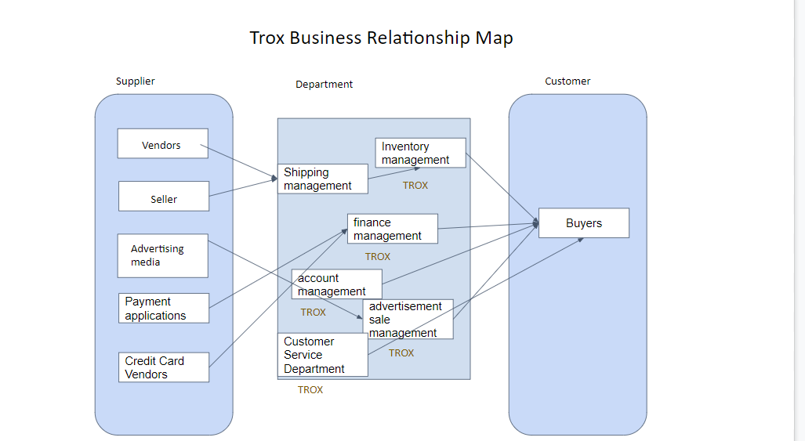

In the above BRM diagram we demonstrate how a customer is mapped to the supplier.

Here we show how a buyer can browse, buy and sell products, how the payment for a product is done and how the user accounts are managed.Here, a vendor’s product first comes to the shipping department from where the product is shipped to the inventory through which it goes to the buyer. Before the product is shipped to the buyer, the buyer is asked to complete the payment process. Here, the buyer can complete the process either by using the payment applications or via credit card vendors through which finance management verifies the details and completes the process. The advertising sale management shows the relevant ads to the buyer based on their preferences. Customer service department provides customer support.

# **Business Requirements**

The primary users of the Trox application will be able to create the account and view a wide range of products available at various price ranges. The portal will provide customers with a user-friendly interface that will allow them to buy, sell,bid and view the products available on the website . The application will also allow users to search for a particular product and the users will also be able to set some filters and preferences which will make their shopping experience more convenient and will allow them to save the time by scrolling through the items that match their preferences and eliminate the products that don’t match their preferences.

## 4.1 Details of Business Requirements

* + 1. **Account Management**

4.1.1.1 Ability to log in

4.1.1.2 Ability to create an account

4.1.1.3 Ability to contact customer support

4.1.1.4 Ability to track orders

4.1.1.5 Ability to view orders

4.1.1.6 Ability to process merchandise payments

* + 1. **Advertising Sales Department** 
       1. Ability to login
       2. Ability to generate ads on the web application
       3. Ability to maintain content of an ad
       4. Ability to filter ads content
       5. Ability to keep ads up to date
       6. Ability to do market analysis
       7. Ability to understand product performance
       8. Ability to promote sponsored posts
    2. **Inventory Department** 
       1. Ability to log in
       2. Ability to add the product name
       3. Ability to upload the product image
       4. Ability to track the progress of an order
       5. Ability to select the category for the product being removed
       6. Ability to select the category for the product being added
       7. Ability to enter the product general information
    3. **Shipping Department** 
       1. Ability to log in
       2. Ability to send the confirmation that order is being prepared
       3. Ability to send the confirmation that the order is ready for delivery
       4. Ability to send the tracking number when order is shipped
       5. Ability to send the confirmation that the order was delivered
       6. Ability to submit the price per subscription plan
       7. Ability to manage the containers of the specific subscription plan
    4. **Customer Service Department**
       1. Ability to respond effectively through the customer support page
       2. Ability to update the open ticket as closed or resolved
       3. Ability to provide the customers with ticket resolution
    5. **Finance Department**
       1. Ability to issue refunds
       2. Ability to process retail merchandise payments
       3. Ability to process seller merchandise payments
       4. Ability to apply/issue discounts
    6. **Buyers requirements** 
       1. Ability to create an account
       2. Ability to delete the account
       3. Ability to modify the account information
       4. Ability to restore the password/user ID details
       5. Ability to sign in to (sign out from) already created account
       6. Ability to read the product information
       7. Ability to add/remove items to/from the cart
       8. Ability to cancel the order before it is prepared for shipping
       9. Ability to create saved preferences
       10. Ability to view the orders history
       11. Ability to enter/modify the delivery address
       12. Ability to provide the additional delivery instructions
       13. Ability to enter/modify the payment information
       14. Ability to submit the form to customer support
       15. Ability to read the resolution of the opened ticket with customer support team
       16. Ability to share the product on social media
       17. Ability to make product favorite
       18. Ability to view the list of favorite products
       19. Ability to leave the reviews
       20. Ability to rate the products

# **Non-Functional Requirements**

| **Category** | **Requirements** |
| --- | --- |
| **Usability** | The application GUI will provide a user-friendly intuitive design with all the features clearly displayed for the user |
| **Usability** | The application navigation will be self-explanatory by clear and concise descriptions and names of each section, as well as features will be clearly evident by proper location and naming |
| **Usability** | Accessibility will be supported for the disabled users as well |
| **Performance** | The application will be supported on different operating systems and browsers, and should not impact the user’s system capabilities |
| **Performance** | The application will be available for 24/7 without any interruptions, and regular maintenances will be scheduled to support the application |
| **Performance** | The application will support the concurrency where the users will be able to simultaneously browse the app, login, make payments, shop the products |
| **Performance** | The application will have short response time to all requests and all the features should be available and not impacted by latency |
| **Security** | The application will be using the automated daily & weekly audits to detect the vulnerabilities. |
| **Security** | The application will use HTTPS protocols for any data exchanges, enforced TLS for all the email communications, and other encryptions that will be maintained on the server |
| **Database** | The application will be using the MySQL database |
| **External System** | The application will be able to interface with the external data feeds from and to payment merchants, ad agencies, social media websites, etc |

# **External Data Feeds**

1. **Payment System(Process Payment,Invoice Creation)**

Allows users to pay for products they buy by authenticating and billing credit cards or other payment methods such as google pay, paypal.

Allows users to recover refunds if there is a problem with the goods in their order by processing refunds and crediting back the amount to their original payment method or as a credit in their trox account.

1. **Ad management(Display Ads)**

The ads platform system will be responsible for feeding sponsored material into the application, contract term, and marketing expenditures.

Trox will provide trend analysts with reports, as well as feed product performance and market analysis into the Ads Platform system.

1. **Shipping management(Ships Products,Tracking System)**

Trox works in a streamlined process, it provides the order and delivery system with accurate shipping information after payment procedure is completed by the user and also notifies the system about it.

Trox provides the users with the tracking ID of their product purchased and along with timely status updates.

1. **Customer Services System(Customer Support)**

Users may utilize a form to contact customer support, submit complaints for resolution, and obtain answers to their questions.

Users may chat with a bot for any discrepancy if they do not wish to wait for customer service executives to help them with their queries.

# **Business Risks**

Online shopping has boomed and evolved over the years and has become an essential part of everyday life. While an ecommerce platform may avoid the risk of customers stealing, it has its own unique problems in the digital business. These risks include the unlawful sharing of data, fraud, security breaches, data privacy laws, online security regulations and customer service issues. Ecommerce's focus is about selling products online and it is critical that the site is secure and customer's data is protected. For one, when a customer is buying a product they will be entering their payment information, address, email and phone number. If that information is stolen it won’t be good for the customer or our application. There is a lot of competition in today's online business, not even to mention the already existing major companies like Amazon, Ebay and many others but also each individual companies offer their own products online like H&M and Nike. In this case a customer will quickly move on to a competitor if they feel like the ecommerce store is not secure and with a new ecommerce store it is hard to gain that first trust.

Some solutions to data privacy and online security risks include restricted access for each employee. Employees should only be able to access files they need. For example, your content creators do not need access to your back-end code. You can also implement two factor authentication. 2FA gives you an added layer of accountability and prevents people from using login credentials that do not belong to them. We can also avoid storing data like payment details locally and only store the customer data that we really need. Another risk to having an online store is if your site suddenly goes down or anything other things that goes wrong on your site. That will leave bad reviews that prevent new customers from visiting your site and take away old customers' trust. With this we have to be careful when we upload new versions or update the application. That also goes into our customer service. Some buyers are buying products from other customers but we are providing the platform for that transaction to take place so we are responsible for both sides of the party’s digital experience. We want customers to keep coming back to our website to do exchange so their feedback and review of our application is very important.